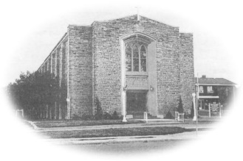
Most Blessed Sacrament Parish
Parish Pastoral Council Minutes
Thursday September 26th , 2019 6:30p.m.

PRESENT: Fr. Charlie, Tom Curtis, Laura Luneberg, Dave Hutchinson Linda Guralski, Lucille DiCenso, Larry Woods, Samantha Galipeau
-----------------------------------------------------------------------------------------

- Opening Prayer

- Pastor’s Report
- Fr. Charlie spoke about the Development and Peace campaign titled “Care for the Earth”. There is a meeting in October he will attend and discuss challenges in South America.
- The 1 heart and 1 soul campaign information packages have been sent out and should be received by the beginning of October.
- There will be a presentation on the campaign at mass on Nov. 30th and Dec. 1st.
- Fr. Charlie is the Bishop’s representative for the diocese regarding sexual misconduct. There is a meeting on Wednesday November 27th at 7:00 pm at Blessed Sacrament parish. This meeting is an open dialogue and both Blessed Sacrament and Sacred Heart are invited.
- Council Report
- On Wednesday November 6th the CWL will have Roman Caruk as a guest speaker discussing Peace and Development issues. The time is to be announced.
- Fundscript cards will only be available once a month. Cards must be paid for upfront when the order is placed.
- The CWL has adopted a child from Guatemala through the Chalice program and is sponsoring a special needs child to go to camp. We pray that both children thrive.
- Tuesday December 10th is the Sacred Heart Social after the 7:00 pm mass. A great evening for the council members.

- Guest Speaker- Rachel presented “Gaps and Goals” from our youth ministry. There is a 3-year plan in effect. The goals will be posted on bulletin boards and in the bulletin. She stressed the need for social media to help in communicating current events in the parish. The PPC will help support these ministry goals.

- Closing Prayer

Next meeting Thursday November 7th, 2019 at 6:30 pm

