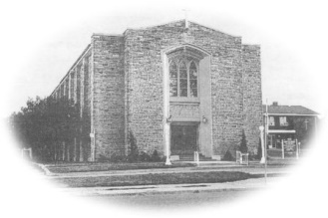
Most Blessed Sacrament Parish
Parish Pastoral Council Minutes
Thursday November 2, 2017 8:00p.m.

PRESENT: Fr. Charlie, Tom Curtis, Brian Shaw, Lucille DiCenso, Larry Woods, Laura Luneberg, Dave Hutchinson, Linda Guralski. REGRETS Samantha Galipeau
-----------------------------------------------------------------------------------------

- Opening Prayer

- Pastor’s Report
- Fr. Charlie shared pamphlets with the council on assisted suicide. This information will be posted on the bulletin boards in the Narthex.
- Final planning is being completed for the upcoming “Seminar of Hope” retreat, November 28,29 and 30th from 7-9p.m. Sister Elaine Arsenault will be leading this event.
- Fr. Charlie discussed parish announcements at mass and explained we will refrain from announcements on holiday weekends.
- Fr. Charlie recently was at a seminar and reviewed the 3 pillars of a thriving parish. He feels confident that our parish is on the right path. Those three things being our Music, the homily focusing on the word of God and our ministries and volunteers.
- Discussed the Christmas mass schedule- December 24th 5:00pm pageant at Blessed Sacrament and 11:00 pm mass
- December 25th 11:00 am Blessed Sacrament
- December 24th 7:00 pm pageant at Sacred Heart
- December 25th 9:00 am Sacred Heart

- Member’s Report
- PPC members need to e-mail Laura by December 3rd, to let her know who is coming to the Sacred Heart Christmas gathering. To take place on Tuesday December 12th, following the 7:00pm mass at Sacred Heart Parish.

- Chair’s Report
  - Nat Filice is coming back to sing Christmas songs on December 6th. All our welcome!

- New Business
  - Rosary club is starting up with Blessed Sacrament school. They will meet every Monday and say the Rosary with the students.
  - Our parish is looking into getting Hamilton Bulldog hockey tickets for family day on February 19th.
  - Social Sunday is booked for the month of February 11/12th in the Narthex.

- Next Meeting
  - Thursday February 8th at 6:30pm

- Closing Prayer

