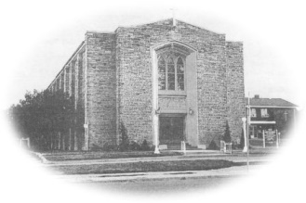
Most Blessed Sacrament Parish
Parish Pastoral Council Minutes
Thursday January19th, 2017 6:30p.m.

PRESENT: Fr Charlie, Tom Curtis, Brian Shaw, Samantha Galipeau, Lucille DiCenso,
Laura Luneberg, Eunice Baldwin, Dave Hutchinson, Maddy Sajder REGRETS: Linda Guralski, Larry Woods
-----------------------------------------------------------------------------------------

- Opening Prayer

- Additions to and Approval of Agenda- okay

- Review of Minutes and Approval of Minutes- accepted

- Business Arising-

- Pastor’s Report- Fr. Charlie

  - Fr. Charlie was pleased with the attendance during our Christmas Masses. The pageant was well done.
  - Discussion of Deacon Ron Jenkins speaking at Mass Jan. 21/22 with regards to sponsorship for children in third world countries. It would be great for our parish to sponsor a child.
  - There is a youth conference in Toronto this summer and our parish will help with fund raising for this event.
  - Easter Mass times were discussed as follows; Holy Thursday 8:00 p.m., Good Friday 3:00 p.m., Holy Saturday 8:00 p.m., Easter Sunday 11:00 a.m.

- Chair’s Report
- Review of the Constitution. The council will make necessary changes at our next meeting.
- A review of security procedures when leaving our parish after Mass. Fr. Charlie is aware of this and will oversee that the church is secured properly.
- A decision was made to give the parishioners a questionnaire about a Town Hall meeting. Would you be willing to attend an evening meeting to discuss our future parish activities? The questionnaire will go out on the weekend of Feb. 11/12 at the masses.

- Council’s Report – The CWL is trying to ban plastic water bottles from Blessed Sacrament. Ideally, no bottled water would be brought into our parish for functions at our church. i.e. picnic, bazaar. The Bishop is in support of this movement as it is a concern with Peace & Development.

- Next meeting date: Thursday March 23rd 2017, 6:30 p.m. Unless, there is a positive response from our survey and the meeting could be earlier.

- Closing Prayer

