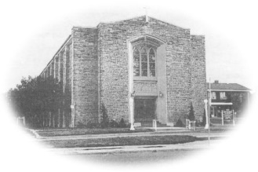
Most Blessed Sacrament Parish
Parish Pastoral Council Minutes
Thursday April 26, 2018 6:30p.m.

PRESENT: Fr. Charlie, Tom Curtis, Laura Luneberg, Dave Hutchinson, Linda Guralski, Brian Shaw REGRETS: Samantha Galipeau, Lucille DiCenso, Larry Woods
-----------------------------------------------------------------------------------------

- Opening Prayer

- Pastor’s Report
- Fr. Charlie confirmed dates for 1st Communion Sunday May 6th at the 11:00 am mass.
- Grade 7 Confirmation Saturday May 12th at the 5:00 pm mass.
- Blessed Sacrament parish picnic will be on Saturday August 18th. Details will follow.
- Parish council BBQ will take place on Thursday June 14th. We welcome council members from Sacred Heart parish. Dinner will be at 7:00 pm. Laura to help organize the menu.
- Congratulations to Fr. Ted he has been named Monsignor and will be celebrating 50 years in the priesthood this June 1st. Fr. Ted will say Mass at Blessed Sacrament June 3rd at the 11:00 am Mass. There will be a reception to follow. CWL will organize. Our parish will present a gift to Fr. Ted at the end of the mass.

- Member’s Report
- VON approached our church for the possibility of an exercise class for parishioners, Linda will inquire and get more information.
- Parish council will have their pictures taken on June 14th at the BBQ. Smile.

- Chair’s Report
  - Members are asked to review notes from our Town Hall meeting last year. This will help in the planning of another social activity/ event. We will discuss this in September.
  - Council members need to inform Laura before June if they are not planning on returning in the Fall.

- Next Meeting Thursday September 20th, 6:30 p.m.

- Closing Prayer

