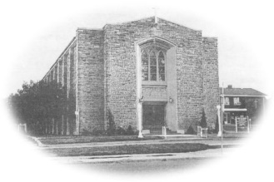
Most Blessed Sacrament Parish
Parish Pastoral Council Minutes
Thursday April 20th, 2017 6:30p.m.

PRESENT: Fr. Charlie, Tom Curtis, Brian Shaw, Samantha Galipeau, Lucille DiCenso, Laura Luneberg, Eunice Baldwin, Dave Hutchinson, Larry Woods, Linda Guralski. REGRETS: Maddy Sajder
-----------------------------------------------------------------------------------------

- Opening Prayer

- Review of Constitution
  - Objectives of the Parish Pastoral Council
    - For council to review wording and decide what changes are needed.

- Town Hall meeting- Summary
  - It was discussed and decided that a brief letter would be written and posted in the bulletin for Sunday April 29th to inform parishioners of upcoming events.
  - Your PPC has decided to concentrate on 2 areas:
    - monthly social activities
    - liturgical and spiritual programs *further specific details to follow this fall

- Volunteer Luncheon
  - To take place on Sunday June 4th after the 11:00 mass, RSVP Linda Guralski
- Parish Council Barbecue
- To take place on Thursday June 22nd, 2017 at 6:30 pm
- We will be inviting Parish Council from Sacred Heart
- Laura to organize the food
- As the date draws closer, each member will email what they are bringing

- Parish Picnic
- To take place on Saturday August 26th after the 5:00 mass

- Chair’s Report
  - Council members will need to decide by June, if they are going to serve another term.

- Closing Prayer

